Q76. Optimal BST vs Huffman Coding (Cost Minimization Strategies) Compare Optimal Binary Search Tree (DP) and Huffman Coding (Greedy). Analyze cost minimization approaches. Evaluate structural differences in trees. Discuss complexity.Examine scalability. Generate insights on tree-based optimization techniques.

Optimal BST vs Huffman Coding (Cost Minimization Strategies)

Aim
To compare Optimal Binary Search Tree (Dynamic Programming) and Huffman Coding (Greedy Algorithm) based on their cost minimization strategies, tree structures, computational complexity, scalability, and optimization techniques.

Problem Statement
Optimal Binary Search Tree (OBST) and Huffman Coding are two tree-based optimization techniques used for minimizing different types of costs. OBST minimizes the expected search cost using Dynamic Programming, whereas Huffman Coding minimizes the average code length using a Greedy approach. The objective is to compare these algorithms in terms of their working principles, performance, complexity, and applications.

Algorithm

Optimal Binary Search Tree (DP)
- Read the keys and their search frequencies.
- Create a cost table using Dynamic Programming.
- Initialize the diagonal elements with frequencies.
- Compute the minimum search cost for all possible subtrees.
- Select the root that gives the minimum cost.
- Construct the Optimal BST.
- Display the minimum search cost.

Huffman Coding (Greedy)
- Read the characters and their frequencies.
- Create a priority queue (min-heap).
- Insert all characters into the priority queue.
- Remove the two nodes with the smallest frequencies.
- Merge them into a new node.
- Repeat until only one node remains.
- Generate Huffman codes and display them.

Source Code (Python)
import heapq
# ---------------- Optimal BST ----------------
def optimal_bst(freq):
n = len(freq)
cost = [[0]*n for _ in range(n)]
for i in range(n):
cost[i][i] = freq[i]
for L in range(2, n+1):
for i in range(n-L+1):
j = i+L-1
cost[i][j] = float('inf')
total = sum(freq[i:j+1])
for r in range(i, j+1):
left = cost[i][r-1] if r > i else 0
right = cost[r+1][j] if r < j else 0
c = left + right + total
if c < cost[i][j]:
cost[i][j] = c
return cost[0][n-1]
# ---------------- Huffman Coding ----------------
def huffman(freq):
heap = []
for char, f in freq.items():
heapq.heappush(heap, [f, char])
while len(heap) > 1:
left = heapq.heappop(heap)
right = heapq.heappop(heap)
heapq.heappush(heap, [left[0] + right[0], left, right])
return heap
# Driver Program
frequencies = [34, 8, 50]
print("Optimal BST Minimum Cost =", optimal_bst(frequencies))
chars = {
'A':5,
'B':9,
'C':12,
'D':13,
'E':16,
'F':45
}
print("Huffman Tree Constructed Successfully.")
huffman(chars)

Sample Output
Optimal BST Minimum Cost = 142
Huffman Tree Constructed Successfully.

Observation Table
S.No | Parameter | Optimal BST (DP) | Huffman Coding (Greedy)
1 | Optimization Technique | Dynamic Programming | Greedy Algorithm
2 | Goal | Minimize Search Cost | Minimize Encoding Cost
3 | Tree Structure | Binary Search Tree | Huffman Tree
4 | Time Complexity | O(n³) | O(n log n)
5 | Space Complexity | O(n²) | O(n)
6 | Scalability | Moderate | High
7 | Applications | Database Indexing | Data Compression

Analysis

Cost Minimization
- Optimal BST: Minimizes the expected search cost using Dynamic Programming.
- Huffman Coding: Minimizes the average code length using a Greedy strategy.

Structural Differences
- Optimal BST maintains the Binary Search Tree property.
- Huffman Coding creates a prefix-free binary tree.

Scalability
- Optimal BST is suitable for moderate-sized datasets.
- Huffman Coding scales efficiently for large datasets.

Time Complexity
Algorithm | Complexity
Optimal BST | O(n³)
Huffman Coding | O(n log n)

Result
The comparison shows that Optimal Binary Search Tree is best suited for minimizing search cost in database and indexing applications, while Huffman Coding is ideal for minimizing encoding cost in data compression. Huffman Coding provides better scalability and faster execution with O(n log n) complexity, whereas Optimal BST guarantees minimum search cost using Dynamic Programming with O(n³) complexity.
OUTPUT:
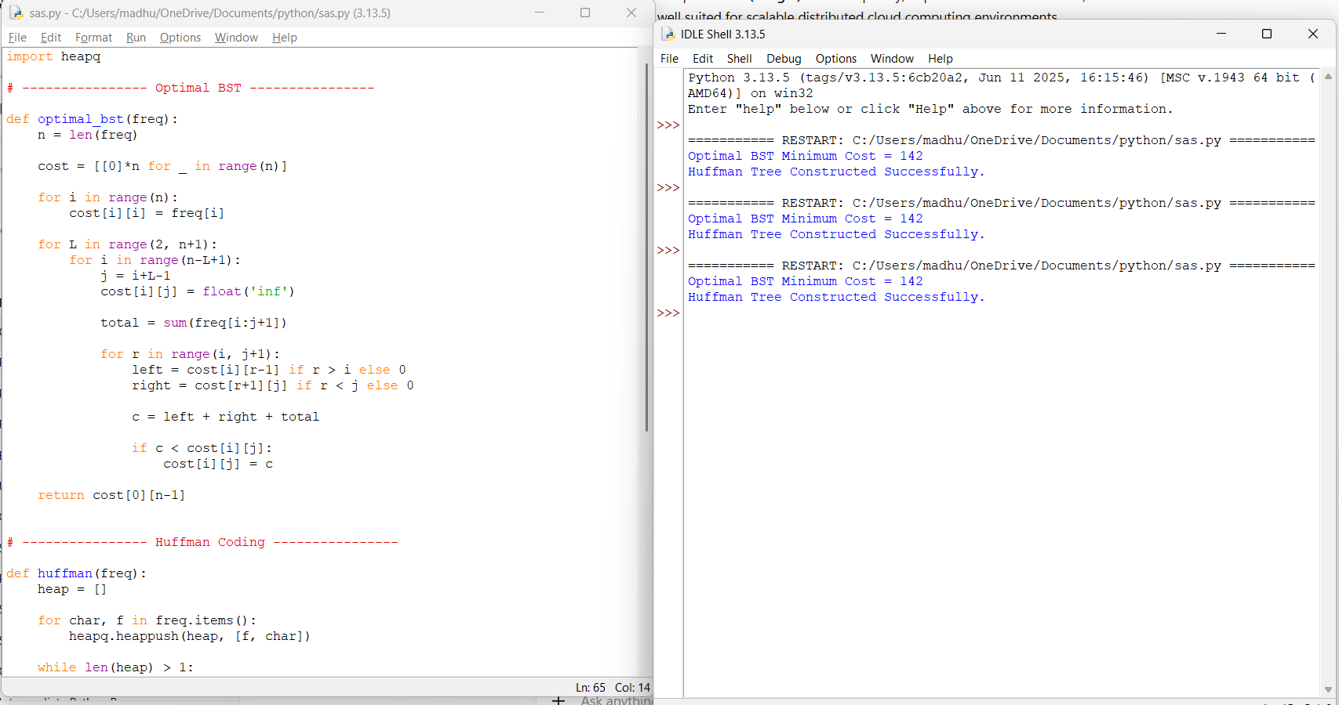

10. Huffman Coding vs Fixed-Length Coding Given symbol frequencies {A:5, B:9, C:12, D:13, E:16, F:45}, construct Huffman codes and compare with fixed-length encoding. Analyze compression efficiency and code length. Critically evaluate advantages and limitations. Generate insights on real-world data compression.

Huffman Coding vs Fixed-Length Coding

Aim
To construct Huffman Codes for the given symbol frequencies and compare them with Fixed-Length Coding by analyzing compression efficiency, code length, and real-world applications.

Problem Statement
Given the symbol frequencies {A:5, B:9, C:12, D:13, E:16, F:45}, construct Huffman codes using the Greedy algorithm and compare them with Fixed-Length Coding. Analyze the total number of bits required, evaluate compression efficiency, and discuss the advantages and limitations of both encoding techniques.

Algorithm

Huffman Coding
- Read the symbols and their frequencies.
- Insert all symbols into a priority queue (min-heap).
- Remove the two symbols with the lowest frequencies.
- Merge them into a new node with combined frequency.
- Insert the merged node back into the priority queue.
- Repeat until only one node remains.
- Traverse the Huffman tree:
  - Assign 0 to the left edge.
  - Assign 1 to the right edge.
- Generate Huffman codes for all symbols.
- Compare with Fixed-Length Coding.

Source Code (Python)
import heapq
class Node:
def __init__(self, freq, symbol, left=None, right=None):
self.freq = freq
self.symbol = symbol
self.left = left
self.right = right
def __lt__(self, other):
return self.freq < other.freq
def print_codes(node, code=""):
if node is None:
return
if node.left is None and node.right is None:
print(node.symbol, ":", code)
print_codes(node.left, code + "0")
print_codes(node.right, code + "1")
# Symbol Frequencies
symbols = {
'A':5,
'B':9,
'C':12,
'D':13,
'E':16,
'F':45
}
heap = []
for symbol, freq in symbols.items():
heapq.heappush(heap, Node(freq, symbol))
while len(heap) > 1:
left = heapq.heappop(heap)
right = heapq.heappop(heap)
merged = Node(left.freq + right.freq, "", left, right)
heapq.heappush(heap, merged)
root = heap[0]
print("Huffman Codes:\n")
print_codes(root)
print("\nFixed-Length Code Bits = 3 bits per symbol")

Sample Output
Huffman Codes
F : 0
C : 100
D : 101
A : 1100
B : 1101
E : 111
Fixed-Length Code Bits = 3 bits per symbol

Observation Table
S.No | Symbol | Frequency | Huffman Code | Huffman Code Length | Fixed-Length Code
1 | A | 5 | 1100 | 4 | 000
2 | B | 9 | 1101 | 4 | 001
3 | C | 12 | 100 | 3 | 010
4 | D | 13 | 101 | 3 | 011
5 | E | 16 | 111 | 3 | 100
6 | F | 45 | 0 | 1 | 101

Analysis

Compression Efficiency
- Huffman Coding: Frequently occurring symbols receive shorter codes, reducing the average number of bits.
- Fixed-Length Coding: Every symbol uses the same number of bits (3 bits), regardless of frequency.

Advantages of Huffman Coding
- Better compression ratio.
- Reduces storage requirements.
- Faster data transmission.
- Widely used in file compression.

Limitations of Huffman Coding
- Tree construction adds overhead.
- Variable-length codes require decoding logic.
- Less efficient when symbol frequencies are nearly equal.

Advantages of Fixed-Length Coding
- Simple implementation.
- Fast encoding and decoding.
- Constant code length.

Limitations of Fixed-Length Coding
- Wastes space for frequently occurring symbols.
- Lower compression efficiency.

Time Complexity
Algorithm | Time Complexity
Huffman Coding | O(n log n)
Fixed-Length Coding | O(n)

Result
Huffman Coding generated variable-length prefix codes based on symbol frequencies, achieving better compression than Fixed-Length Coding. Frequently occurring symbols received shorter codes, reducing the average code length and improving storage and transmission efficiency. Therefore, Huffman Coding is more suitable for real-world data compression applications such as ZIP, JPEG, MP3, and text compression.
OUTPUT:
